# [1] Update to Name of folder and files

* Change the name of the folder to “SW_RunProcessTool”
* Change the name of the python file to “SW_RunProcess”
* Change the name of the json config file to “SW_RunProcessConfig”

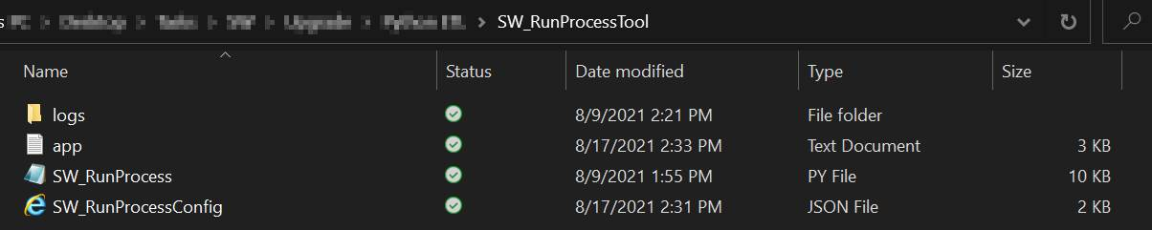

# [2] Update value in code

* We noticed an error with the value for ‘true’ in the code
* Line 95, ‘True’ must be changed to ‘true’

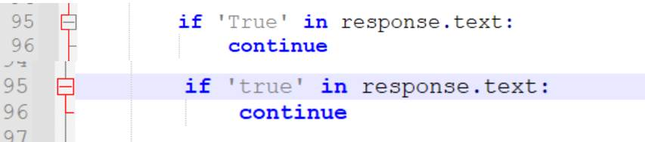

[3] Do not run disabled processes

* In our testing, we noticed that the script also runs processes that are disabled (users enable/disable processes at specific times based on their timely needs). Disabled processes should NOT be executed
* Modify the python script such that it also checks if the sched-procname is enabled. This can be seen in the JSON query see below have an ‘activation’ value of ‘Enabled’.
* If the ‘activation’ value of the scheduler process is not equal to ‘Enabled’, terminate the process with value 1 and log output: “**Process terminated. Process: <sched-procname> is disabled!**”
* In line 302, you obtain processID for sched-procname. That function calls the below JSON, which returns 1 entry for each scheduler process. Here is an example of a sched-procName called “Tools”. Activation value is shown in green. Use this step to also gather / capture the activation status of the scheduler process, and act accordingly.

{'id': 1, 'name': 'Tools', 'scheduleItemType': 'Folder', 'order': 0, 'lastRun': '2015-02-26T22:45:26.49Z', 'lastRunStatus': 'Error', 'activation': 'Enabled', 'nextRun': '0001-01-01T00:00:00', 'childScheduleItems': [{'executable': 'ReadTimeTable.cmd', 'arguments': 'ReadTimeTable.cmd', 'id': 10, 'name': 'ReadTimeTable.cmd', 'scheduleItemType': 'ExternalTool', 'order': 0, 'lastRun': '2015-02-26T23:03:44.78Z', 'lastRunStatus': 'Success', 'activation': 'Enabled', 'nextRun': '0001-01-01T00:00:00', 'parent': 1, 'settings': {'schedulerSettingsId': 0, 'scheduleItemId': 10, 'emailOnFailure': False, 'emailOnSuccess': False, 'stopOnFailure': False, 'stopToolOnTimeout': False, 'isGlobal': True, 'overrideChildSettings': False, 'successEmails': [], 'failEmails': [], 'externalToolTimeout': 0, 'enableRetries': False, 'version': {'rowVersion': 90182}}, 'version': {'rowVersion': 94037}}, {'id': 1029, 'name': 'Account Import Test', 'scheduleItemType': 'Import', 'order': 1, 'lastRun': '0001-01-01T00:00:00', 'lastRunStatus': 'None', 'activation': 'Disabled', 'nextRun': '0001-01-01T00:00:00', 'parent': 1, 'settings': {'schedulerSettingsId': 0, 'scheduleItemId': 1029, 'emailOnFailure': False, 'emailOnSuccess': False, 'stopOnFailure': False, 'stopToolOnTimeout': False, 'isGlobal': True, 'overrideChildSettings': False, 'successEmails': [], 'failEmails': [], 'externalToolTimeout': 0, 'enableRetries': False, 'version': {'rowVersion': 90182}}, 'version': {'rowVersion': 821058}}], 'settings': {'schedulerSettingsId': 0, 'scheduleItemId': 1, 'emailOnFailure': False, 'emailOnSuccess': False, 'stopOnFailure': False, 'stopToolOnTimeout': False, 'isGlobal': True, 'overrideChildSettings': False, 'successEmails': [], 'failEmails': [], 'externalToolTimeout': 0, 'enableRetries': False, 'version': {'rowVersion': 90182}}, 'version': {'rowVersion': 94036}}

[4] No reporting on disabled child-tasks

* Modify the python script such that the log file does not output any status messages for child-tasks of sched-procname that are not enabled
* Similar to the above, any child-task of a scheduler process can be disabled. Disabled tasks don’t get executed, and thus should NOT be in the output
* In line 287, the code loops through all items in sched-procname and picks the details.
* It should only pick the details for child-tasks that have activation status = enabled (as noted in yellow above).

Example:



The squared line is disabled, and thus should not have this output in the log file.

[5] New Wait-time variable

* Currently, the script is using the “wait_time_global_action” parameter to both wait for a global action to complete, and wait for the scheduler process to complete.
* Create a new separate parameter to be used for to wait for the scheduler process to complete running (Line 191)
* New variable = “wait_time_process_execution”

[6] Cosmetic change to the log outputs

Line 305, change

f"Process Id cannot be found for Process Name: {options.sched_procname}!")

to

f"Process terminated. Process: {options.sched_procname} cannot be found!")

Line 310, change

logger.error("Trigger Files Not Found!")

to

logger.error("Process terminated. Trigger Files Not Found!")

Line 314, change

logger.error("Global Action ongoing!")

to

logger.error("Process terminated. Global Action ongoing!")